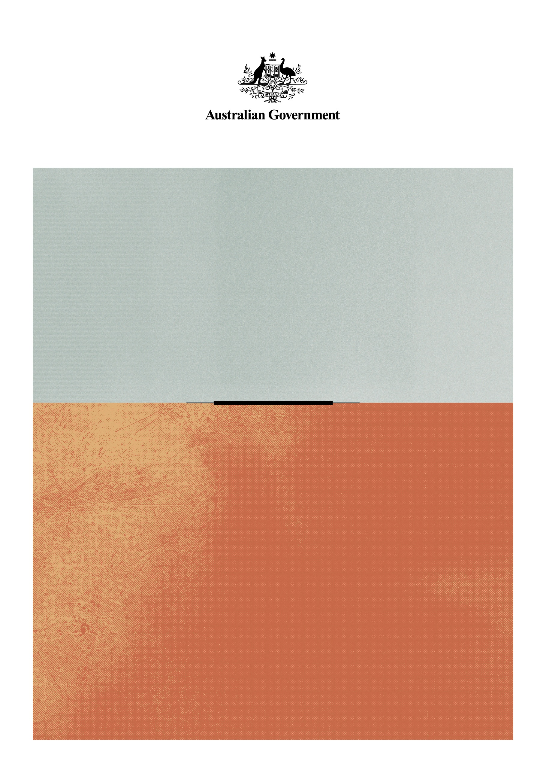

Towards a new National Cultural Policy
  - Public Consultation Paper
March 2026

© Commonwealth of Australia 2026

Ownership of intellectual property rights in this publication
Unless otherwise noted, copyright (and any other intellectual property rights, if any) in this publication is owned by the Commonwealth of Australia (referred to below as the Commonwealth).

Disclaimer
The material contained in this publication is made available on the understanding that the Commonwealth is not providing professional advice, and that users exercise their own skill and care with respect to its use, and seek independent advice if necessary.
The Commonwealth makes no representations or warranties as to the contents or accuracy of the information contained in this publication. To the extent permitted by law, the Commonwealth disclaims liability to any person or organisation in respect of anything done, or omitted to be done, in reliance upon information contained in this publication.

Creative Commons licence


With the exception of (a) the Coat of Arms; (b) the Department of Infrastructure, Transport, Regional Development, Communications, Sport and the Arts photos and graphics; (c) content supplied by third parties; (d) content otherwise labelled; copyright in this publication is licensed under a Creative Commons BY Attribution 4.0 International Licence.

Use of the Coat of Arms
The Department of the Prime Minister and Cabinet (PM&C) sets the terms under which the Coat of Arms is used. Please refer to the Commonwealth Coat of Arms Information and Guidelines | PM&C.

Contact us
This publication is available in Word format. All other rights are reserved, including in relation to any departmental logos or trademarks which may exist. For enquiries regarding the licence and any use of this publication, please contact:
Office for the Arts
Email: culturalpolicy@arts.gov.au
Website: www.arts.gov.au/culturalpolicy

Minister’s message
Cultural policy isn't just a set of announcements about the arts. The whole concept is to make sure the arts aren't simply an afterthought about entertainment alone. It's about making sure we consider the place of culture in Australia.
Just over three years ago, we launched Australia’s first National Cultural Policy in more than ten years - Revive: A place for every story, a story for every place. Revive restored culture to be at the centre of our national life. It reinforced that arts and culture are not a luxury, they are essential to our economy, our wellbeing, and our sense of belonging. Revive recognised the essential work of Australian creatives, positioning arts workers as real workers who make substantial contributions to Australia’s economic and cultural life.
Through Revive we established Creative Australia – one body to support the government funded, philanthropic and commercial sectors. Creative Australia is dedicated to Australian stories and Australian creativity in all its forms. We now have Music Australia to support the music sector, Creative Workplaces to support arts workers, Writing Australia to support the literature sector and First Nations Arts, to provide First Nations peoples with autonomy to make funding decisions.
Revive has, as its name intended, helped to revive the sector.
Now, as we look to the next chapter, the government wants to hear from you about what comes next. This will be the first time in Australia's history that we will have consecutive national cultural policies. We want to hear from you about how we can continue to build a cultural landscape that reflects our diversity, supports our art workers, and strengthens the nation we share.
The development of a new cultural policy is the next chapter in a story that stretches back to the first sunrise on our continent. I don't know where the next cultural policy is going to take us. But I do know this. If we get it right, it will help us see ourselves more clearly and as we learn about each other, the world will come to know us better.

The Hon Tony Burke MP
Minister for the Arts
March 2026

Why start on the next National Cultural Policy now?
When Revive was launched in January 2023, it set out a bold five-year plan to rebuild and renew arts and culture in Australia. As this plan has now passed its halfway point, and in line with the Policy’s original timetable, it is time to take stock of what has been achieved and to consider the road ahead.
What Revive delivered
As of March 2026, 75 of the 85 actions in Revive have been delivered. We have:
- Established Creative Australia and its new councils — Music Australia, Writing Australia, Creative Workplaces and First Nations Arts — giving artists and communities a direct voice in strategic investment.
- Supported the commercial sector through targeted investment with Music Australia and the Creative Futures Fund.
- Invested funding to secure the future of our national collecting institutions and national arts training organisations.
- Released Equity: The Arts and Disability Plan 2022–2026, providing a national framework to strengthen access, inclusion and representation for d/Deaf and disabled artists and audiences.
- Introduced the Digital Games Tax Offset to grow the capacity of Australia’s digital games and screen sectors.
- Established an Australian content requirement for streaming services to ensure that no matter what screen you are watching, you will have guaranteed access to Australian stories.
- Increased the Location Offset to 30 per cent, to encourage large scale screen productions to film in Australia.
- Improved access to information and resources for creative workers and arts organisations to understand and deliver fair, safe and respectful workplaces through the establishment of Creative Workplaces.
- Delivered new funding and partnership programs to boost regional creativity, community festivals, touring, skills development and youth engagement, including providing a critical lifeline for live music through Revive Live.
- Loaned 333 works of art to 42 institutions under the Sharing the National Collection initiative to take some of the world’s best artwork out of storage in the National Gallery of Australia and display it around Australia.
- Funded specialist in-school arts education programs that directly draw from cultural and creative sector expertise, to support creative practice in Australian classrooms.

Revive has helped to reshape arts and culture in Australia, what’s next?
Since Revive, the way arts and culture are created, shared and experienced has continued to evolve.
Digital tools and platforms are changing how creative work is produced, distributed and discovered. This is expanding access while also raising questions about authenticity, creative rights and fair remuneration.
Audiences are engaging across live, digital and hybrid experiences, with expectations around access, discoverability and participation also continuing to evolve. At the same time, rising costs and financial pressures are highlighting the importance of resilient systems and infrastructure.
Across communities, cultural participation continues to play an important role in how people connect, share experience and engage with each other. From local activity to national events, arts and culture provide spaces for participation, dialogue and shared experience across many different settings.
Younger people in particular are engaging with culture in new ways, both as creators and audience members, using digital environments to collaborate and tell stories in new forms. These shifts are shaping future skills, creative pathways and patterns of participation.
Global demand for cultural content is also growing, opening opportunities for Australian stories, art, music, design, screen and games to reach audiences beyond our borders. Australia’s position in the competitive global environment will influence our ability to retain creative talent and connect with international markets over time.
Together, these factors underscore consideration of how Australia’s cultural policy settings can remain relevant, effective and forward-looking.
Why culture matters: Delivering for Australia
Arts and culture shape how we see ourselves and how the world sees us. They strengthen our communities, drive innovation, and help us navigate the challenges of a changing world.
Culture drives prosperity and innovation: In 2023-24 cultural and creative activity contributed $67.4 billion to Australia’s economy and employed over 591,000 people. Beyond direct economic contribution, culture fosters creativity, design thinking and problem-solving capabilities, and is increasingly recognised as important for innovation and productivity in the workforce.
Culture connects people and builds resilience: Participation in culture is linked to stronger communities, better mental health and higher civic trust. From local libraries and choirs to major festivals, culture fosters belonging and strengthens community resilience.
Culture defines Australia: Through culture, we continue to express and define our relationship to the world around us. First Nations cultures are Australia’s oldest continuing heritage and a defining source of cultural strength. This enriches our national story and advances reconciliation. Our creative exports, including works of art, music, stories, dance, games, film and design, contribute to diplomacy and how Australia is seen and understood globally.

The Framework: Five Pillars of Australia’s Cultural Policy
The next National Cultural Policy will continue to be built around the five pillars first set out in Revive.

Pillar 1 — First Nations First
Recognising and respecting the crucial place of First Nations stories at the centre of Australia’s arts and culture.
The government is seeking views on how cultural policy can continue to reflect First Nations priorities, strengthen recognition of cultural rights, recognise the centrality of language to culture, and support pathways for First Nations leadership across the cultural landscape.

Pillar 2 — A Place for Every Story
Reflecting the breadth of our stories and the contribution of all Australians as the creators of culture.
The government is seeking views on how cultural policy can continue to recognise diverse forms of cultural expression and participation, including local and place-based practice and emerging modes of expression, while responding to changing patterns of participation and supporting inclusion.

Pillar 3 — Centrality of the Artist
Supporting the artist as worker and celebrating artists as creators.
As creative practice, technology and work patterns continue to evolve, the government is seeking views on how cultural policy can respond to changing conditions for creative work, including safer and fairer workplaces, the protection of creative rights in the digital environment and the role of arts education, creative skills and lifelong learning, and how creators are recognised across the broader economy.

Pillar 4 — Strong Cultural Infrastructure
Providing support across the spectrum of institutions which sustain our arts, culture and heritage.
The government is seeking views on how Australia’s cultural infrastructure can remain resilient, adaptable and fit-for-purpose, including how existing partnerships, investment, infrastructure and systems could be used more effectively to support long-term sustainability.

Pillar 5 — Engaging the Audience
Making sure our stories connect with people at home and abroad.
The government is seeking views on how cultural policy can respond to changing audience behaviours, discovery pathways and modes of engagement, including innovation in presentation and discovery to sustain participation, as well as marketing and distribution so Australian creativity continues to inspire, include and connect.

Have Your Say: Shaping the next chapter
Australia’s story is still being written. Every artist, arts worker, audience member, organisation and community contributes to that story through creativity, participation and the ideas that shape our future.
The government is seeking your input to help guide the next National Cultural Policy, a forward-looking framework that will shape how we support and celebrate arts and culture over the coming years.
We want to hear your views on:
- the challenges and opportunities you see in the pillar or pillars most relevant to you
- why the five pillars matter to you and your practice, and/or
- what you would like to see reflected in the next National Cultural Policy.

How to contribute
Make a submission: Share your ideas, insights and experiences about what’s working, what’s changing and what the next chapter of Australian culture looks like to you.
Have your say, visit www.arts.gov.au/culturalpolicy
Stay informed: Updates, key dates and resources will be available through the Office for the Arts website www.arts.gov.au/culturalpolicy
Arts and culture reflect who we are, and shape who we become. By sharing your ideas and experiences, you’re helping to shape a cultural legacy for generations to come.
Have your say. Share your story. Help write Australia’s next creative chapter.

